

LENANA SCHOOL 2025 PREDICTION
POSSIBLE KCSE EXAM
CHEMISTRY
(THEORY)
233/1
PAPER 1
TIME: 2 HOURS

NAME……………………………………………………………………………………….
SCHOOL……………………………………………… SIGN………………………..
INDEX NO……………………………………………. ADM NO……………………

Kenya Certificate of Secondary Education.

INSTRUCTIONS TO CANDIDATES
(a). Write your name class and class number in the spaces provided above
(b) Sign and write the date of the examination in the spaces provided above
(c) Answer ALL questions in the spaces provided.
(d) Mathematical tables and electronic calculators may be used.
(e) All working must be shown clearly where necessary.

FOR EXAMINER’S USE ONLY
Questions | Maximum score | Candidates score
1 – 27 | 80

Answer ALL questions in the spaces provided.
1 (a) What is a universal indicator? (1mark)
.....................................................................................................................
.....................................................................................................................

(b) State one advantage of universal indicator over other commercial indicators. (1mark)
.....................................................................................................................
.....................................................................................................................

2. Complete the diagram below on identification and uses of some laboratory apparatus.
Diagram | 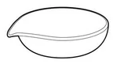 | 
Name | (a)  (½ mark) | (c)  (½ mark)
Purpose | (b)  (1mark) | (d)  (1mark)

3 (a) In an experiment, sulphur was heated in a deflagrating spoon until it begins to burn then lowered into a gas jar. Explain the observations made. (2 marks)
.....................................................................................................................
.....................................................................................................................
.....................................................................................................................

(b) Explain the role of oxygen in steel making. (2 marks)
.....................................................................................................................
.....................................................................................................................
.....................................................................................................................
4 (a) State Graham’s law of diffusion. (1mark)
.....................................................................................................................
.....................................................................................................................

(b) At what temperature, in K, assuming constant pressure, is the volume of a fixed mass of gas at 127ºC doubled? (2 marks)

5 (a) Distinguish between a temporary physical change and temporary chemical change.(2 marks)
.....................................................................................................................
.....................................................................................................................
.....................................................................................................................
.....................................................................................................................

(b) In an experiment, the following substances were heated in separate test tubes. Complete the table to state the observations and classifying the type of change that occurs. (3 marks)
Solid | Observations on heating | Type of change
CuSO₄.5H₂O
KMnO₄

6. Explain how you would distinguish between ethane and ethyne. (2 marks)
.....................................................................................................................
.....................................................................................................................
.....................................................................................................................

7. Explain how solid calcium sulphate can be prepared from solid samples of calcium carbonate and sodium sulphate. All other reagents and apparatus are provided. (3 marks)
.....................................................................................................................
.....................................................................................................................
.....................................................................................................................
.....................................................................................................................
.....................................................................................................................

8 (a)A metal reacts with dilute hydrochloric acid to produce a gas. Explain how to identify the gas.
(1mark)
.....................................................................................................................
.....................................................................................................................

(b) The diagram below shows the set up used for the reaction between magnesium and steam.
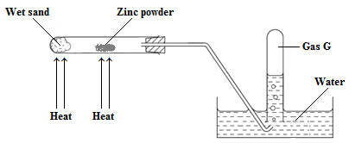
(i) Explain the observations made. (2 marks)
.....................................................................................................................
.....................................................................................................................
.....................................................................................................................

(ii) Explain why the wet sand must be heated first before the zinc powder is heated. (1mark)
.....................................................................................................................
.....................................................................................................................

9 (a) Distinguish between covalent bond and co-ordinate bond. (2 marks)
.....................................................................................................................
.....................................................................................................................
.....................................................................................................................
.....................................................................................................................

(b) The diagram below shows the structure of a covalent compound containing the element hydrogen, H, and the unknown elements X, Y and Z.
To which groups of the Periodic Table do these three elements, X, Y and Z, belong? (1½ marks)

10. In an experiment silicon (IV) chloride is dissolved in water in a boiling tube.
(a) Write an equation for the reaction that occurs. (1mark)

(b) Explain the observations that were made during the experiment. (3 marks)
.....................................................................................................................
.....................................................................................................................
.....................................................................................................................
.....................................................................................................................
.....................................................................................................................

11. A standard solution of potassium hydroxide (KOH) is prepared in a 250 cm³ volumetric flask. During a titration, 12.5 cm³ of this solution neutralizes 25 cm³ of a 0.16 moldm⁻³ ethanoic acid solution.
The balanced equation for the reaction is: CH₃COOH_{(aq)} + KOH_{(aq)} → CH₃COOK_{(aq)} + H₂O_{(l)}
Calculate the mass of potassium hydroxide used to prepare the solution above in the 250 cm³ volumetric flask. (K = 39, O = 16.0, H = 1.) (3 marks)

12. Ammonia gas was burnt in oxygen as shown in the diagram below.
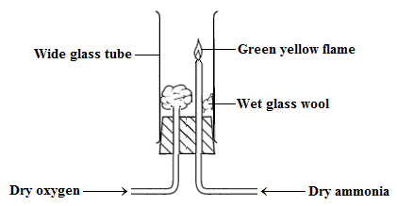
(a) State the role of the glass wool. (1mark)
.....................................................................................................................
.....................................................................................................................
(b) State the observations made during the experiment. (1mark)
.....................................................................................................................
.....................................................................................................................
(c) Write an equation for the reaction that occurs. (1mark)

13. Study the following reaction at equilibrium at a certain temperature.
2SO_{3(g)} ⇌ O_{2(g)} + 2SO_{2(g)} ΔH > 0
(a) State two optimum conditions for this reaction. (1mark)
.....................................................................................................................
.....................................................................................................................

(b) State two ways of increasing the yield of SO_{3(g)}. (2 marks)
.....................................................................................................................
.....................................................................................................................

14 (a) Write the equation for the reaction between chlorine and cold dilute sodium hydroxide. (1mark)

(b) When chlorine gas reacts with hot concentrated calcium hydroxide, one of the products formed is calcium hypochlorite (CaOCl₂). This commonly referred to as bleaching powder.
Explain the bleaching action of calcium hypochlorite. (2 marks)
.....................................................................................................................
.....................................................................................................................
.....................................................................................................................

15. The diagram below shows an apparatus for the laboratory preparation of carbon (II) oxide.
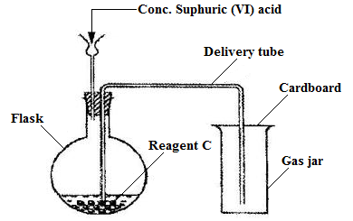
(a) Identify two mistakes in the set up. (2 marks)
.....................................................................................................................
.....................................................................................................................
.....................................................................................................................

(b) Write an equation for the reaction between concentrated sulphuric (VI) acid and reagent C. (1mark)

(c) State one use of carbon (II) oxide. (1mark)
.....................................................................................................................
.....................................................................................................................

16. The structures of four organic compounds are shown.
(a) Which compounds decolourize bromine water? (1mark)
.....................................................................................................................
.....................................................................................................................

(b) Explain one chemical test that can be used to distinguish between compounds 1 and 2. (2 marks)
.....................................................................................................................
.....................................................................................................................
.....................................................................................................................

17. How does the number of carbon, hydrogen and oxygen atoms in an ester differ from the total number of carbon, hydrogen and oxygen atoms in the alcohol and carboxylic acid from which the compound was derived? (1½ marks)
.....................................................................................................................
.....................................................................................................................
.....................................................................................................................
.....................................................................................................................
.....................................................................................................................

18. The diagram shows a reaction scheme.
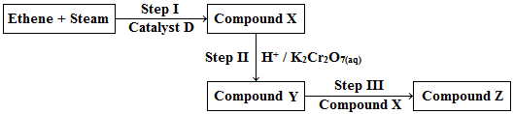
(a) Name:
(i) Catalyst D

(ii) Reaction II

(iii) Reaction III

(iv) Compound Z (4 marks)

(b) State the observations made in step II. (1mark)
.....................................................................................................................
.....................................................................................................................

(c) Write an equation for the reaction that occurs in step III. (1mark)
.....................................................................................................................
.....................................................................................................................
19. A student performs two reactions.
- reaction 1: 10 g of magnesium ribbon with excess 2.0 mol / dm³ dilute hydrochloric acid
- reaction 2: 5 g of magnesium powder with excess 2.0 mol / dm³ dilute hydrochloric acid
In both experiments, the volume of hydrogen produced, V, is measured against time, t, and the results plotted graphically.
(a) On the grid below, sketch a graph that would be obtained is volume of hydrogen produced is plotted against time for both reactions1 and 2. (2 marks)

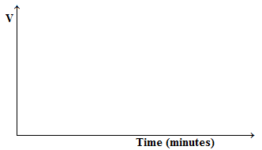
(b) Explain your answers. (2 marks)
.....................................................................................................................
.....................................................................................................................
.....................................................................................................................
.....................................................................................................................

20. A copper – zinc electrochemical cell is set up as shown below.
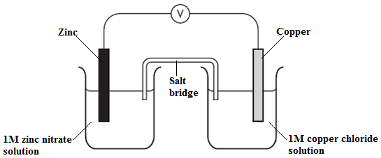

Lead (II) nitrate is used as an electrolyte in the salt bridge.
(a) Initially the cell did not work. Explain. (2 marks)
.....................................................................................................................
.....................................................................................................................
.....................................................................................................................

(b) Once the mistake identified in (a) above was corrected:
(i) Write the equation for the reaction at the anode. (1mark)
.....................................................................................................................
.....................................................................................................................

(ii) Determine the E.m.f of the cell given that: (2 marks)
Zn_{(s)} → Zn²⁺_{(aq)} + 2e; E^{Ɵ} + 0.76V
Cu_{(s)} → Cu²⁺_{(aq)} + 2e; E^{Ɵ} – 0.34V

21. When a solution containing silver ions is added to a solution containing iron (II) ions, an equilibrium is set up.
2Ag⁺_{(aq)} + Fe²⁺_{(aq)} ⇌ 2Ag_{(s)} + Fe³⁺_{(aq)}
(Green) (Yellow)
Explain the effect of addition of silver nitrate to the equilibrium mixture. (2 marks)
.....................................................................................................................
.....................................................................................................................
.....................................................................................................................

22 (a) One of the ores of sodium is saltpetre. Give the formula of saltpetre. (1mark)
.....................................................................................................................
.....................................................................................................................
(b) In the Down’s cell, the anode is made of carbon while the cathode is made of steel. Steel is a reactive electrode and would make the electrolytic process faster. Explain why it is not used at the anode despite this advantage. (1mark)
.....................................................................................................................
.....................................................................................................................

(c) Write two equations that occur at the anode during the electrolysis process. (2 marks)
.....................................................................................................................
.....................................................................................................................
.....................................................................................................................

23 (a) What is half life as used in radioactivity? (1mark)
.....................................................................................................................
.....................................................................................................................
(b) A certain nuclide has a half-life of 1.5 seconds.
(i) What is a nuclide? (1mark)
.....................................................................................................................
.....................................................................................................................

(ii) What percentage of a given mass of the nuclide will be left after 7.5 hours? (2 marks)

24. The potential energy graph for a hypothetical chemical reaction is shown below.
(a) What type of reaction is taking place? (1mark)
.....................................................................................................................
.....................................................................................................................

(b) What are the correct methods to calculate ΔH and E_{a}? (2 marks)
.....................................................................................................................
.....................................................................................................................
.....................................................................................................................
.....................................................................................................................

25. The diagram shows the apparatus used to electrolyse lead (II) bromide using inert electrodes.
Why does the lamp light up only when the lead (II) bromide is melted? (2 marks)
.....................................................................................................................
.....................................................................................................................
.....................................................................................................................

